

July 19, 2012

Mr. Clark Arneson
City of Blaine
10801 Tow Square Drive NE
Blaine, MN 55449

RE: APPROVAL OF 2013 NORTH METRO TELECOMMUNICATIONS COMMISSION BUDGET

Dear Clark:

Enclosed, please find for the council’s review and approval the 2013 North Metro Telecommunications Commission Budget.

The Commission’s operating budget for 2013 is proposed at $1,066,443. This number represents an $11,396 (1.08%) increase over last year’s operating budget. The increase is due to a 2% increase for North Metro TV staff, and an increase in benefits to reflect the benefits paid by the Member Cities to their employees for 2012. The remainder of the budget remains at the 2012 levels.

Budgeted capital costs for 2013 are higher than in 2012. It is important that several video systems be upgraded. All equipment purchases will maintain the integrity and safety of the current systems, while moving North Metro TV toward a tapeless and HD environment. The capital budget totals $446,493. This number also covers routine computer/software upgrades, a fleet vehicle, and the bond payment for the building ($182,493).

Franchise fees paid back to the Member Cities are budgeted at $285,000. This is the same as last year's franchise fee payment.

Recommendation: That the Member Cities approve the 2013 Commission Budget as recommended by the Telecommunications Commission and the Operations Committee.

The Joint Powers Agreement states, “submitted budgets shall be deemed approved
by a Member City unless, prior to October 15 preceding the effective date of the
proposed budget, the Member City gives notice in writing to the Commission that it is
withdrawing from the Commission.”

12520 Polk Street Northeast, Blaine, MN 55434 Phone: (612) 780-8241 Fax: (612) 780-8242
Blaine   Centerville  Circle Pines  Ham Lake  Lexington   Lino Lakes   Spring Lake Park

Page 2

I want to thank the Commission directors, staff, and the Operations Committee for their efforts in preparing these budgets. If you have any questions about either budget please consult with your Commission director or City Administrator.

I look forward to working with all parties, throughout the remainder of 2012, toward reaching the full potential of North Metro TV and to increase both the quality and quantity of community programming and services in 2013.

Sincerely,

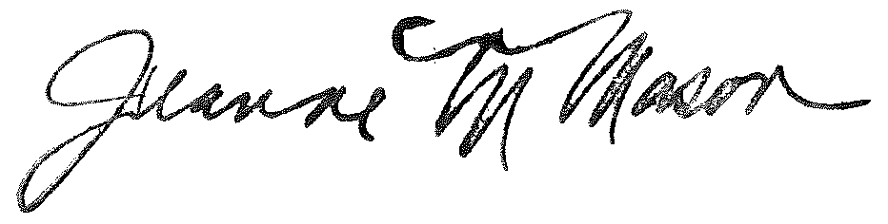

Jeanne Mason
Chair, North Metro Telecommunications Commission

Enc.

