Extract of Minutes of Meeting of the
City Council of the City of Blaine
Counties of Anoka and Ramsey, Minnesota

Pursuant to due call and notice thereof, a regular meeting of the City Council of the City of Blaine, Minnesota, was duly held in the City Hall in the City, on Thursday, July 12, 2018, commencing at 7:30 p.m., C.T.

The following members were present:

and the following were absent:

*** *** ***

The Mayor announced that the next order of business was consideration of the proposals which had been received for the purchase of the City’s $30,105,000 General Obligation Water Revenue Bonds, Series 2018B.

The City Finance Director presented a tabulation of the proposals that had been received in the manner specified in the Terms of Proposal for the Bonds. The proposals were as set forth in Exhibit A attached hereto.

After due consideration of the proposals, Councilmember ___________________ introduced the following resolution and moved its adoption.
RESOLUTION NO. __________

RESOLUTION AWARDING THE SALE OF $30,105,000 GENERAL OBLIGATION WATER REVENUE BONDS, SERIES 2018B FIXING THEIR FORM AND SPECIFICATIONS; DIRECTING THEIR EXECUTION AND DELIVERY; AND PROVIDING FOR THEIR PAYMENT.

BE IT RESOLVED By the City Council of the City of Blaine, Minnesota (the “City”) as follows:

Section 1. Background.

1.01 The City is authorized by Minnesota Statutes, Chapters 444 and 475, as amended (the “Act”), to finance all or a portion of the cost of improvements to the water utility system within the City, including construction of a water treatment plant and well house rehabilitation (the “Utility Improvements”) by the issuance of General Obligation Water Revenue Bonds of the City payable from the net revenues of the water utility system of the City.

1.02 The City is authorized by Minnesota Statutes, Section 475.60, subdivision 2(9) to negotiate the sale of the Bonds, it being determined that the City has retained an independent municipal advisor in connection with such sale. The actions of the City staff and the City’s municipal advisor in negotiating the sale of the Bonds are ratified and confirmed in all aspects.

Section 2. Sale of Bonds.

2.01 Authorization. It is hereby determined that it is necessary to provide financing for the Utility Improvements and to finance those Utility Improvements through issuance of the City’s $30,105,000 General Obligation Water Revenue Bonds, Series 2018B (the “Bonds”).

2.02. Award to the Purchaser and Interest Rates. The proposal of Raymond James & Associates, Inc., in St. Petersburg, Florida (the “Purchaser”) to purchase the Bonds of the City hereby found and determined to be a reasonable offer and is hereby accepted, the proposal being to purchase the Bonds at a price of $32,837,990.00 (par amount of $30,105,000, plus a premium of $2,862,441.50, less underwriter’s discount of $129,451.50), plus accrued interest to date of delivery, if any, for Bonds bearing interest as follows:

Year of Maturity |  | Interest  Rate |  | Year of Maturity |  | Interest  Rate
2021 |  | 5.00% |  | 2031 |  | 4.00%
2022 |  | 5.00% |  | 2032 |  | 3.00%
2023 |  | 5.00% |  | 2033 |  | 3.125%
2024 |  | 5.00% |  | 2034 |  | 4.00%
2025 |  | 5.00% |  | 2035 |  | 4.00%
2026 |  | 5.00% |  | 2036 |  | 4.00%
2027 |  | 5.00% |  | 2037 |  | 4.00%
2028 |  | 5.00% |  | 2038 |  | 4.00%
2029 |  | 5.00% |  | 2039 |  | 3.375%
2030 |  | 4.00%

2.03. Purchase Contract. Any amount paid by the Purchaser over the minimum purchase price shall be credited to the Debt Service Fund hereinafter created, or deposited in the Construction Fund hereinafter created, as determined by the City Finance Director in consultation with the City’s municipal advisor. The City Finance Director is directed to retain the good faith check of the Purchaser, pending completion of the sale of the Bonds, and to return the good faith checks of the unsuccessful proposers. The Mayor and City Manager are authorized to execute a contract with the Purchaser on behalf of the City, if requested by the Purchaser.

2.04. Terms and Principal Amount of the Bonds. The City will forthwith issue and sell the Bonds pursuant to the Act, in the total principal amount of $30,105,000, originally dated as of the date of delivery, the Bonds being in fully registered form and issued in the denomination of $5,000 each or any integral multiple thereof, numbered No. R-1 and upward, bearing interest as above set forth, and maturing on February 1 in the years and amounts as follows:

Year |  | Amount |  | Year |  | Amount
2021 |  | $ 620,000 |  | 2031 |  | $1,730,000
2022 |  | 655,000 |  | 2032 |  | 1,800,000
2023 |  | 680,000 |  | 2033 |  | 1,850,000
2024 |  | 1,240,000 |  | 2034 |  | 1,910,000
2025 |  | 1,300,000 |  | 2035 |  | 1,985,000
2026 |  | 1,370,000 |  | 2036 |  | 2,065,000
2027 |  | 1,435,000 |  | 2037 |  | 2,150,000
2028 |  | 1,510,000 |  | 2038 |  | 2,235,000
2029 |  | 1,585,000 |  | 2039 |  | 2,325,000
2030 |  | 1,660,000

As may be requested by the Purchaser, one or more term Bonds may be issued having mandatory sinking fund redemption and final maturity amounts conforming to the foregoing principal repayment schedule, and corresponding additions may be made to the provisions of the applicable Bond(s).

2.05. Optional Redemption. The City may elect on February 1, 2028, and on any day thereafter to prepay Bonds maturing on or after February 1, 2029. Redemption may be in whole or in part and if in part, at the option of the City and in such manner as the City will determine. If less than all Bonds of a maturity are called for redemption, the City will notify DTC (as defined in Section 7 hereof) of the particular amount of such maturity to be prepaid. DTC will determine by lot the amount of each participant’s interest in such maturity to be redeemed and each participant will then select by lot the beneficial ownership interests in such maturity to be redeemed. Prepayments will be at a price of par plus accrued interest.

Section 3. Form, Registration and Payment.

3.01. Registered Form. The Bonds will be issued only in fully registered form. The interest thereon and, upon surrender of each Bond, the principal amount thereof is payable by check or draft issued by the Registrar described herein.

3.02. Dates; Interest Payment Dates. Each Bond will be dated as of the last interest payment date preceding the date of authentication to which interest on the Bond has been paid or made available for payment, unless (i) the date of authentication is an interest payment date to which interest has been paid or made available for payment, in which case the Bond will be dated as of the date of authentication, or (ii) the date of authentication is prior to the first interest payment date, in which case the Bond will be dated as of the date of original issue. The interest on the Bonds is payable on February 1 and August 1 of each year, commencing August 1, 2019, to the registered owners thereof of record as of the close of business on the 15th day of the immediately preceding month, whether or not that day is a business day.

3.03. Registration. The City will appoint a bond registrar, transfer agent, authenticating agent and paying agent (the “Registrar”). The effect of registration and the rights and duties of the City and the Registrar with respect thereto are as follows:

(a) Register. The Registrar will keep at its principal corporate trust office a bond register in which the Registrar provides for the registration of ownership of Bonds and the registration of transfers and exchanges of Bonds entitled to be registered, transferred or exchanged.

(b) Transfer of Bonds. Upon surrender for transfer of a Bond duly endorsed by the registered owner thereof or accompanied by a written instrument of transfer, in form satisfactory to the Registrar, duly executed by the registered owner thereof or by an attorney duly authorized by the registered owner in writing, the Registrar will authenticate and deliver, in the name of the designated transferee or transferees, one or more new Bonds of a like aggregate principal amount and maturity, as requested by the transferor. The Registrar may, however, close the books for registration of any transfer after the 15th day of the month preceding each interest payment date and until that interest payment date.

(c) Exchange of Bonds. Whenever any Bonds are surrendered by the registered owner for exchange the Registrar will authenticate and deliver one or more new Bonds of a like aggregate principal amount and maturity as requested by the registered owner or the owner’s attorney in writing.

(d) Cancellation. All Bonds surrendered upon any transfer or exchange will be promptly cancelled by the Registrar and thereafter disposed of as directed by the City.

(e) Improper or Unauthorized Transfer. When a Bond is presented to the Registrar for transfer, the Registrar may refuse to transfer the Bond until the Registrar is satisfied that the endorsement on the Bond or separate instrument of transfer is valid and genuine and that the requested transfer is legally authorized. The Registrar will incur no liability for the refusal, in good faith, to make transfers which it, in its judgment, deems improper or unauthorized.

(f) Persons Deemed Owners. The City and the Registrar may treat the person in whose name a Bond is at any time registered in the bond register as the absolute owner of such Bond, whether the Bond is overdue or not, for the purpose of receiving payment of, or on account of, the principal of and interest on the Bond and for all other purposes, and payments so made to a registered owner or upon the owner’s order will be valid and effectual to satisfy and discharge the liability upon the Bond to the extent of the sum or sums so paid.

(g) Taxes, Fees and Charges. The Registrar may impose a charge upon the owner thereof for a transfer or exchange of Bonds, sufficient to reimburse the Registrar for any tax, fee or other governmental charge required to be paid with respect to the transfer or exchange.

(h) Mutilated, Lost, Stolen or Destroyed Bonds. If a Bond becomes mutilated or is destroyed, stolen or lost, the Registrar will deliver a new Bond of like amount, number, maturity date and tenor in exchange and substitution for and upon cancellation of the mutilated Bond or in lieu of and in substitution for any Bond destroyed, stolen or lost, upon the payment of the reasonable expenses and charges of the Registrar in connection therewith; and, in the case of a Bond destroyed, stolen or lost, upon filing with the Registrar of evidence satisfactory to it that the Bond was destroyed, stolen or lost, and of the ownership thereof, and upon furnishing to the Registrar an appropriate bond or indemnity in form, substance and amount satisfactory to it and as provided by law, in which both the City and the Registrar must be named as obligees. Bonds so surrendered to the Registrar will be cancelled by the Registrar and evidence of such cancellation must be given to the City. If the mutilated, destroyed, stolen or lost bond has already matured or been called for redemption in accordance with its terms it is not necessary to issue a new Bond prior to payment.

(i) Redemption. In the event any of the Bonds are called for redemption, notice thereof identifying the Bonds to be redeemed will be given by the Registrar by mailing a copy of the redemption notice by first class mail (postage prepaid) to the registered owner of each Bond to be redeemed at the address shown on the registration books kept by the Registrar and by publishing the notice if required by law. Failure to give notice by publication or by mail to any registered owner, or any defect therein, will not affect the validity of the proceedings for the redemption of Bonds. Bonds so called for redemption will cease to bear interest after the specified redemption date, provided that the funds for the redemption are on deposit with the place of payment at that time.

3.04. Appointment of Initial Registrar. The City appoints U.S. Bank National Association, St. Paul, Minnesota, as the initial Registrar. The Mayor and the City Manager are authorized to execute and deliver, on behalf of the City, a contract with the Registrar. Upon merger or consolidation of the Registrar with another corporation, if the resulting corporation is a bank or trust company authorized by law to conduct such business, the resulting corporation is be authorized to act as successor Registrar. The City agrees to pay the reasonable and customary charges of the Registrar for the services performed. The City reserves the right to remove the Registrar upon 30 days’ notice and upon the appointment of a successor Registrar, in which event the predecessor Registrar must deliver all cash and Bonds in its possession to the successor Registrar and deliver the bond register to the successor Registrar. On or before each principal or interest due date, without further order of this Council, the City Finance Director must transmit to the Registrar moneys sufficient for the payment of all principal and interest then due.

3.05. Execution, Authentication and Delivery. The Bonds will be prepared under the direction of the City Finance Director and executed on behalf of the City by the signatures of the Mayor and the City Manager, provided that all signatures may be printed, engraved or lithographed facsimiles of the originals. If an officer whose signature or a facsimile of whose signature appears on the Bonds ceases to be such officer before the delivery of any Bond, that signature or facsimile will nevertheless be valid and sufficient for all purposes, the same as if the officer had remained in office until delivery. Notwithstanding such execution, a Bond will not be valid or obligatory for any purpose or entitled to any security or benefit under this Resolution unless and until a certificate of authentication on the Bond has been duly executed by the manual signature of an authorized representative of the Registrar. The Certificates of authentication on different Bonds need not be signed by the same representative. The executed certificate of authentication on a Bond is conclusive evidence that it has been authenticated and delivered under this Resolution. When the Bonds have been so prepared, executed and authenticated, the City Finance Director will deliver the same to the Purchaser thereof upon payment of the purchase price in accordance with the contract of sale heretofore made and executed, and the Purchaser is not obligated to see to the application of the purchase price.

3.06. Temporary Bonds. The City may elect to deliver in lieu of printed definitive Bonds one or more typewritten temporary Bonds in substantially the form set forth in Exhibit B with such changes as may be necessary to reflect more than one maturity in a single temporary bond. Upon the execution and delivery of the definitive Bonds the temporary Bonds will be exchanged therefor and cancelled.

3.07. Form of Bonds. The Bonds will be printed or typewritten in substantially the form set forth in Exhibit B attached hereto.

3.08. Approving Legal Opinion. The City Finance Director is authorized and directed to obtain a copy of the proposed approving legal opinion of Kennedy & Graven, Chartered, Minneapolis, Minnesota, which will be complete except as to dating thereof and to cause the opinion to be printed or accompany each Bond.

Section 4. Funds and Accounts; Security; Payment.

4.01. Debt Service Fund. The Bonds will be payable from the General Obligation Water Revenue Bonds, Series 2018B Debt Service Fund (the “Debt Service Fund”) hereby created. The Debt Service Fund shall be administered and maintained by the City Finance Director as a bookkeeping account separate and apart from all other funds maintained in the official financial records of the City.

The City will continue to maintain and operate its Water Utility Fund, to which will be credited all gross revenues of the water utility system (the “Utility System”), and out of which will be paid all normal and reasonable expenses of current operations of such Utility System. Any balances therein are deemed net revenues (the “Net Revenues”) and will be transferred, from time to time, to the Debt Service Fund hereby created, which fund will be used only to pay principal of and interest on the Bonds, and any other bonds similarly authorized. There will always be retained in the Debt Service Fund a sufficient amount to pay principal of and interest on all of the Bonds, and the City Finance Director must report any current or anticipated deficiency in the Debt Service Fund to the City Council. If a payment of principal or interest on the Bonds becomes due when there is not sufficient money in the Debt Service Fund to pay the same, the City Finance Director is directed to pay such principal or interest from the general fund of the City, and the general fund will be reimbursed for the advances out of the proceeds of net revenues of the Water Utility Fund and taxes when collected. There is also appropriated to the Debt Service Fund (i) capitalized interest financed from the Bond proceeds, if any; (ii) any amount over the minimum purchase price of the Bonds paid by the Purchaser, to the extent designated for deposit in the Debt Service Fund in accordance with Section 2.03, if any; and (iii) the accrued interest paid by the Purchaser upon closing and delivery of the Bonds, if any.

4.02. Construction Fund. The City hereby creates the General Obligation Water Revenue Bonds, Series 2018B Construction Fund (the “Construction Fund”) to be administered and maintained by the Finance Director as a bookkeeping account separate and apart from all other funds maintained in the official financial records of the City. Proceeds of the Bonds, less the appropriations made in Section 4.01 hereof, together with any other funds appropriated during the construction of the Utility Improvements financed by the Bonds will be deposited in the Construction Fund to be used solely to defray expenses of the Utility Improvements. When the Utility Improvements are completed and the cost thereof paid, the Construction Fund is to be closed and any funds remaining may be deposited in Debt Service Fund.

4.03. City Covenants. The City Council covenants and agrees with the holders of the Bonds that so long as any of the Bonds remain outstanding and unpaid, it will keep and enforce the following covenants and agreements:

(a) The City will continue to maintain and efficiently operate the Utility System as public utilities and conveniences free from competition of other like municipal utilities and will cause all revenues therefrom to be deposited in bank accounts and credited to the Utility System accounts as hereinabove provided, and will make no expenditures from those accounts except for a duly authorized purpose and in accordance with this resolution.

(b) The City will also maintain the Debt Service Fund as a separate account and will cause money to be credited thereto from time to time, out of Net Revenues from the Utility System in sums sufficient to pay principal of and interest on the Bonds when due.

(c) The City will keep and maintain proper and adequate books of records and accounts separate from all other records of the City in which will be complete and correct entries as to all transactions relating to the Utility System and which will be open to inspection and copying by any bondholder, or the bondholder's agent or attorney, at any reasonable time, and it will furnish certified transcripts therefrom upon request and upon payment of a reasonable fee therefor, and said account will be audited at least annually by a qualified public accountant and statements of such audit and report will be furnished to all bondholders upon request.

(d) This Council will cause persons handling revenues of the Utility System to be bonded in reasonable amounts for the protection of the City and the bondholders and will cause the funds collected on account of the operations of the Utility System to be deposited in a bank whose deposits are guaranteed under the Federal Deposit Insurance Law.

(e) The City will keep the Utility System insured at all times against loss by fire, tornado and other risks customarily insured against with an insurer or insurers in good standing, in such amounts as are customary for like plants, to protect the holders, from time to time, of the Bonds and the City from any loss due to any such casualty and will apply the proceeds of such insurance to make good any such loss.

(f) The City and each and all of its officers will punctually perform all duties with reference to the Utility System as required by law.

(g) The City will impose and collect charges of the nature authorized by Minnesota Statutes, Section 444.075 at the times and in the amounts required to produce Net Revenues adequate to pay all principal and interest when due on the Bonds and to create and maintain such reserves securing said payments as may be provided in this resolution.

(h) This Council will levy general ad valorem taxes on all taxable property in the City, when required to meet any deficiency in pledged Net Revenues.

(i) The City hereby determines that the estimated collection of Net Revenues herein pledged for the payment of principal and interest on the Bonds will produce at least 5% in excess of the amount needed to meet, when due, the principal and interest payments on the Bonds.

4.04. County Auditors’ Certificates as to Registration. The City Clerk is authorized and directed to file a certified copy of this resolution with the County Auditor of Anoka and Ramsey Counties and to obtain the certificate required by Minnesota Statutes, Section 475.63.

4.05. General Obligation Pledge. For the prompt and full payment of the principal of and interest on the Bonds, as the same respectively become due, the full faith, credit and taxing powers of the City will be and are hereby irrevocably pledged. If the balance in the Debt Service Fund is ever insufficient to pay all principal and interest then due on the Bonds and any other bonds payable therefrom, the deficiency will be promptly paid out of monies in the general fund of the City which are available for such purpose, and such general fund may be reimbursed with or without interest from the Debt Service Fund when a sufficient balance is available therein.

Section 5. Authentication of Transcript; Execution of Related Documents.

5.01. City Proceedings and Records. The officers of the City are authorized and directed to prepare and furnish to the Purchaser and to the attorneys approving the Bonds, certified copies of proceedings and records of the City relating to the Bonds and to the financial condition and affairs of the City, and such other certificates, affidavits and transcripts as may be required to show the facts within their knowledge or as shown by the books and records in their custody and under their control, relating to the validity and marketability of the Bonds and such instruments, including any heretofore furnished, may be deemed representations of the City as to the facts stated therein.

5.02. Certification as to Official Statement. The Mayor, City Manager and Finance Director are authorized and directed to certify that they have examined the Official Statement, prepared and circulated in connection with the issuance and sale of the Bonds and that to the best of their knowledge and belief the Official Statement is, as of the date thereof, a complete and accurate representation of the facts and representations made therein as it relates to the City.

5.03. Other Certificates. The Mayor, City Manager, and Finance Director are hereby authorized and directed to furnish to the Purchaser at the closing such certificates as are required as a condition of sale. Unless litigation shall have been commenced and be pending questioning the Bonds or the organization of the City or incumbency of its officers, at the closing the Mayor, City Manager, and Finance Director shall also execute and deliver to the Purchaser a suitable certificate as to absence of material litigation, and the Finance Director shall also execute and deliver a certificate as to payment for and delivery of the Bonds.

Section 6. Tax Covenant.

6.01 Tax-Exempt Bonds. The City covenants and agrees with the holders from time to time of the Bonds that it will not take or permit to be taken by any of its officers, employees, or agents any action which would cause the interest on the Bonds to become subject to taxation under the Internal Revenue Code of 1986, as amended (the “Code”), and the Treasury Regulations promulgated thereunder, in effect at the time of such actions, and that it will take or cause its officers, employees or agents to take, all affirmative action within its power that may be necessary to ensure that such interest will not become subject to taxation under the Code and applicable Treasury Regulations, as presently existing or as hereafter amended and made applicable to the Bonds. To that end, the City will comply with all requirements necessary under the Code to establish and maintain the exclusion from gross income of the interest on the Bonds under Section 103 of the Code, including without limitation requirements relating to temporary periods for investments, limitations on amounts invested at a yield greater than the yield on the Bonds

6.02. Rebate Required. The City shall comply with requirements necessary under the Code to establish and maintain the exclusion from gross income of the interest on the Bonds under Section 103 of the Code, including without limitation (1) requirements relating to temporary periods for investments, (2) limitations on amounts invested at a yield greater than the yield on the Bonds, and (3) the rebate of excess investment earnings to the United States unless the Bonds qualify for an exception to the rebate requirement under the Code and related Treasury Regulations.

6.03. Not Private Activity Bonds. The City further covenants not to use the proceeds of the Bonds or to cause or permit them or any of them to be used, in such a manner as to cause the Bonds to be “private activity bonds” within the meaning of Sections 103 and 141 through 150 of the Code.

6.04. No Designation of Qualified Tax-Exempt Obligations. The Bonds have not been designated as “qualified tax-exempt obligations” within the meaning of Section 265(b)(3) of the Code.

6.05. Procedural Requirements. The City will use its best efforts to comply with any federal procedural requirements which may apply in order to effectuate the designations made by this section.

Section 7. Book-Entry System; Limited Obligation of City.

7.01. DTC. The Bonds will be initially issued in the form of a separate single typewritten or printed fully registered Bond for each of the maturities set forth in Section 2.04 hereof. Upon initial issuance, the ownership of each Bond will be registered in the registration books kept by the Registrar in the name of Cede & Co., as nominee for The Depository Trust Company, New York, New York, and its successors and assigns (“DTC”). Except as provided in this section, all of the outstanding Bonds will be registered in the registration books kept by the Registrar in the name of Cede & Co., as nominee of DTC.

7.02. Participants. With respect to Bonds registered in the registration books kept by the Registrar in the name of Cede & Co., as nominee of DTC, the City, the Registrar and the Paying Agent will have no responsibility or obligation to any broker dealers, banks and other financial institutions from time to time for which DTC holds Bonds as securities depository (the “Participants”) or to any other person on behalf of which a Participant holds an interest in the Bonds, including but not limited to any responsibility or obligation with respect to (i) the accuracy of the records of DTC, Cede & Co. or any Participant with respect to any ownership interest in the Bonds, (ii) the delivery to any Participant or any other person (other than a registered owner of Bonds, as shown by the registration books kept by the Registrar) of any notice with respect to the Bonds, including any notice of redemption, or (iii) the payment to any Participant or any other person, other than a registered owner of Bonds, of any amount with respect to principal of, premium, if any, or interest on the Bonds. The City, the Registrar and the Paying Agent may treat and consider the person in whose name each Bond is registered in the registration books kept by the Registrar as the holder and absolute owner of such Bond for the purpose of payment of principal, premium and interest with respect to such Bond, for the purpose of registering transfers with respect to such Bond, and for all other purposes. The Paying Agent will pay all principal of, premium, if any, and interest on the Bonds only to or on the order of the respective registered owners, as shown in the registration books kept by the Registrar, and all such payments will be valid and effectual to fully satisfy and discharge the City’s obligations with respect to payment of principal of, premium, if any, or interest on the Bonds to the extent of the sum or sums so paid. No person other than a registered owner of Bonds, as shown in the registration books kept by the Registrar, will receive a certificated Bond evidencing the obligation of this resolution. Upon delivery by DTC to the City Manager of a written notice to the effect that DTC has determined to substitute a new nominee in place of Cede & Co., the words “Cede & Co.,” will refer to such new nominee of DTC; and upon receipt of such a notice, the City Manager will promptly deliver a copy of the same to the Registrar and Paying Agent.

7.03. Representation Letter. The City has heretofore executed and delivered to DTC a Blanket Issuer Letter of Representations (the “Representation Letter”) which will govern payment of principal of, premium, if any, and interest on the Bonds and notices with respect to the Bonds. Any Paying Agent or Registrar subsequently appointed by the City with respect to the Bonds will agree to take all action necessary for all representations of the City in the Representation Letter with respect to the Registrar and Paying Agent, respectively, to be complied with at all times.

7.04. Transfers Outside Book-Entry System. In the event the City, by resolution of the City Council, determines that it is in the best interests of the persons having beneficial interests in the Bonds that they be able to obtain Bond certificates, the City will notify DTC, whereupon DTC will notify the Participants, of the availability through DTC of Bond certificates. In such event the City will issue, transfer and exchange Bond certificates as requested by DTC and any other registered owners in accordance with the provisions of this Resolution. DTC may determine to discontinue providing its services with respect to the Bonds at any time by giving notice to the City and discharging its responsibilities with respect thereto under applicable law. In such event, if no successor securities depository is appointed, the City will issue and the Registrar will authenticate Bond certificates in accordance with this resolution and the provisions hereof will apply to the transfer, exchange and method of payment thereof.

7.05. Payments to Cede & Co. Notwithstanding any other provision of this Resolution to the contrary, so long as a Bond is registered in the name of Cede & Co., as nominee of DTC, payments with respect to principal of, premium, if any, and interest on the Bond and notices with respect to the Bond will be made and given, respectively in the manner provided in DTC’s Operational Arrangements, as set forth in the Representation Letter.

Section 8. Continuing Disclosure.

8.01. City Compliance with Provisions of Continuing Disclosure Certificate. The City hereby covenants and agrees that it will comply with and carry out all of the provisions of the Continuing Disclosure Certificate. Notwithstanding any other provision of this Resolution, failure of the City to comply with the Continuing Disclosure Certificate is not to be considered an event of default with respect to the Bonds; however, any Bondholder may take such actions as may be necessary and appropriate, including seeking mandate or specific performance by court order, to cause the City to comply with its obligations under this section.

8.02. Execution of Continuing Disclosure Certificate. “Continuing Disclosure Certificate” means that certain Continuing Disclosure Certificate executed by the Mayor and City Manager and dated the date of issuance and delivery of the Bonds, as originally executed and as it may be amended from time to time in accordance with the terms thereof.

Section 9. Defeasance. When the Bonds and all interest thereon, have been discharged as provided in this section, all pledges, covenants and other rights granted by this resolution to the holders of the Bonds will cease, except that the pledge of the full faith and credit of the City for the prompt and full payment of the principal of and interest on the Bonds will remain in full force and effect. The City may discharge Bonds which are due on any date by depositing with the Registrar on or before that date a sum sufficient for the payment thereof in full or by depositing irrevocably in escrow, with a suitable institution qualified by law as an escrow agent for this purpose, cash or securities which are backed by the full faith and credit of the United States of America, or any other security authorized under Minnesota law for such purpose, bearing interest payable at such times and at such rates and maturing on such dates and in such amounts as shall be required and sufficient, subject to sale and/or reinvestment in like securities, to pay said obligation(s), which may include any interest payment on such Bond and/or principal amount due thereon at a stated maturity (or if irrevocable provision shall have been made for permitted prior redemption of such principal amount, at such earlier redemption date). If any Certificate should not be paid when due, it may nevertheless be discharged by depositing with the Registrar a sum sufficient for the payment thereof in full with interest accrued to the date of such deposit.

The motion for the adoption of the foregoing resolution was duly seconded by Member ____________, and upon vote being taken thereon, the following voted in favor thereof:

Councilmembers _______

and the following voted against the same:

whereupon said resolution was declared duly passed and adopted.
STATE OF MINNESOTA )
)
COUNTIES OF ANOKA )
AND RAMSEY ) SS.
)
CITY OF BLAINE )

I, the undersigned, being the duly qualified and acting City Clerk of the City of Blaine, Minnesota, do hereby certify that I have carefully compared the attached and foregoing extract of minutes of a regular meeting of the City Council held on Thursday, July 12, 2018, with the original thereof on file in my office and I further certify that the same is a full, true and correct transcript therefrom insofar as the same relates to the issuance and sale of the City’s $30,105,000 General Obligation Water Revenue Bonds, Series 2018B.
WITNESS My hand as City Clerk and the corporate seal of the City this 12th day of July, 2018.

City Clerk
City of Blaine, Minnesota
EXHIBIT A

PROPOSALS

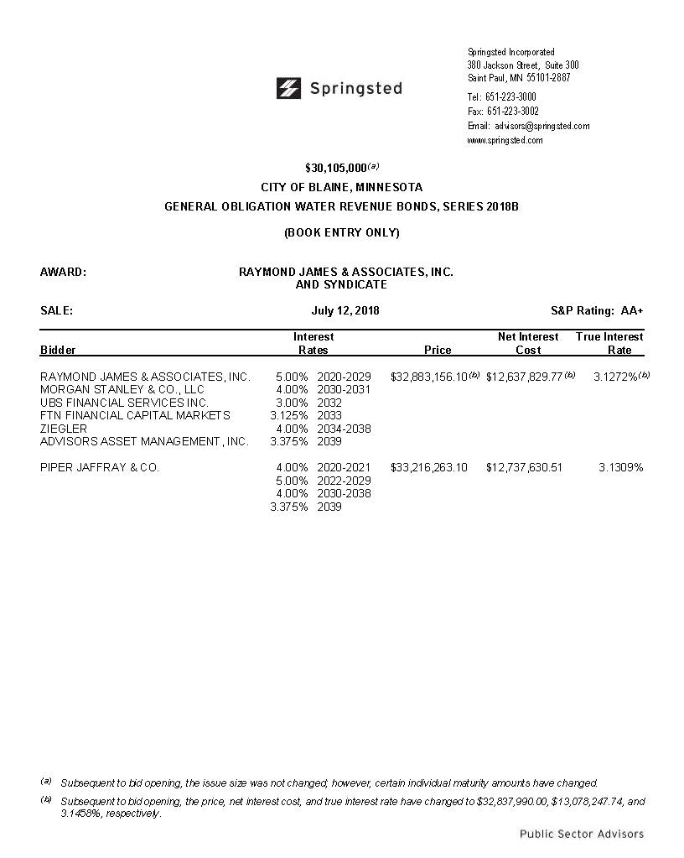
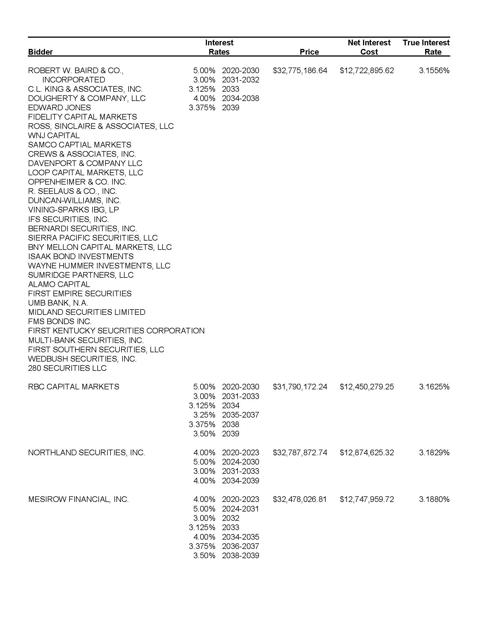
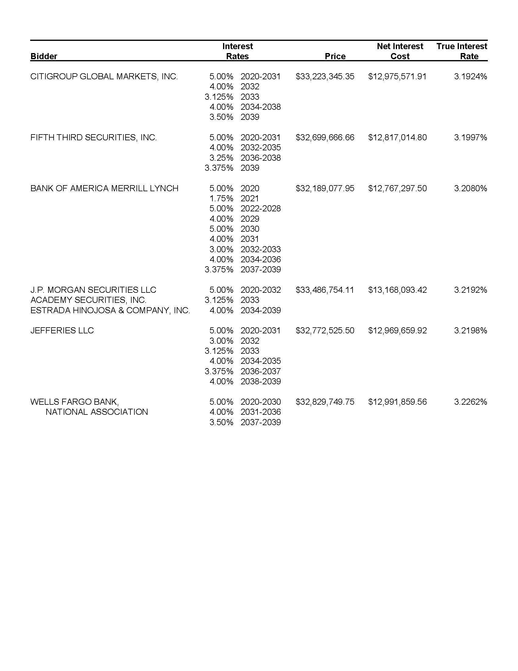
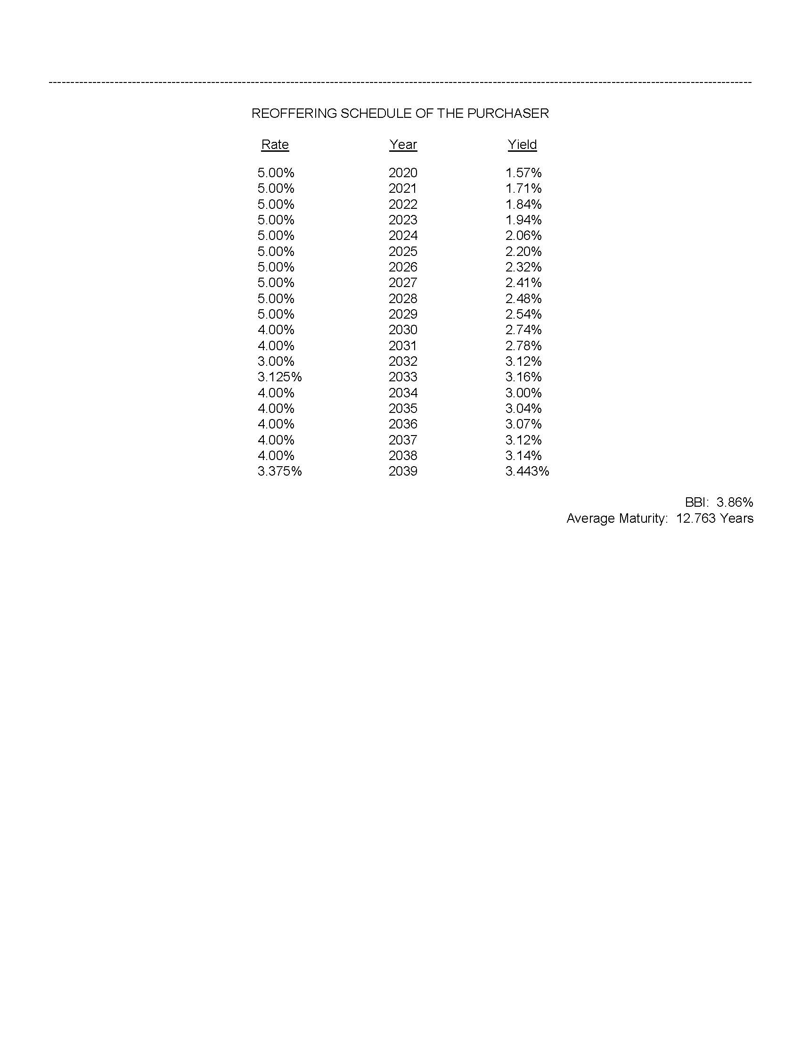

EXHIBIT B

FORM OF BOND

No. R-_____ UNITED STATES OF AMERICA $__________
STATE OF MINNESOTA
COUNTIES OF ANOKA AND RAMSEY
CITY OF BLAINE

GENERAL OBLIGATION
WATER REVENUE BOND, SERIES 2018B

Rate |  | Maturity Date |  | Date of  Original Issue |  | CUSIP
 |  | February 1, 20____ |  | ____________, 2018

Registered Owner: Cede & Co.

The City of Blaine, Minnesota, a duly organized and existing municipal corporation in Anoka and Ramsey Counties, Minnesota (the “City”), acknowledges itself to be indebted and for value received hereby promises to pay to the Registered Owner specified above or registered assigns, the principal amount set forth above on the maturity date specified above, with interest thereon from the date hereof at the annual rate specified above (calculated on the basis of a 360 day year of twelve 30 day months), payable February 1 and August 1 in each year, commencing August 1, 2019, to the person in whose name this Bond is registered at the close of business on the 15th day (whether or not a business day) of the immediately preceding month. The interest hereon and, upon presentation and surrender hereof, the principal hereof are payable in lawful money of the United States of America by check or draft by U.S. Bank National Association, St. Paul, Minnesota, as Registrar, Authenticating Agent and Paying Agent, or its designated successor under the Resolution described herein. For the prompt and full payment of such principal and interest as the same respectively become due, the full faith and credit and taxing powers of the City have been and are hereby irrevocably pledged.

This Bond is one of an issue in the aggregate principal amount of $30,105,000, all of like original issue date and tenor, except as to number, maturity date, redemption privilege, and interest rate, issued pursuant to a resolution adopted by the City Council on July 12, 2018 (the “Resolution”), for the purpose of financing various utility improvements and pursuant to and in full conformity with the Constitution, laws of the State of Minnesota, including Minnesota Statutes, Chapter 475, as amended and Minnesota Statutes, Section 444.075. The principal hereof and interest hereon are payable primarily from the net revenues of the water system of the City in a special debt service fund of the City, as set forth in the Resolution to which reference is made for a full statement of rights and powers thereby conferred. The full faith and credit of the City are irrevocably pledged for payment of this Bond and the City Council has obligated itself to levy ad valorem taxes on all taxable property in the City in the event of any deficiency in net revenues, taxes may be levied without limitation as to rate or amount. The Bonds of this series are issued only as fully registered Bonds in denominations of $5,000 or any integral multiple thereof of single maturities.

The City may elect on February 1, 2028, and on any date thereafter to prepay Bonds maturing on or after February 1, 2029. Redemption may be in whole or in part and if in part, at the option of the City and in such order as the City will determine. If less than all Bonds of a maturity are called for redemption, the City will notify The Depository Trust Company (“DTC”) of the particular amount of such maturity to be prepaid. DTC will determine by lot the amount of each participant’s interest in such maturity to be redeemed and each participant will then select by lot the beneficial ownership interests in such maturity to be redeemed. Prepayments will be at a price of par plus accrued interest.

As provided in the Resolution and subject to certain limitations set forth therein, this Bond is transferable upon the books of the City at the principal office of the Registrar, by the registered owner hereof in person or by the owner’s attorney duly authorized in writing upon surrender hereof together with a written instrument of transfer satisfactory to the Registrar, duly executed by the registered owner or the owner’s attorney; and may also be surrendered in exchange for Bonds of other authorized denominations. Upon such transfer or exchange the City will cause a new Bond or Bonds to be issued in the name of the transferee or registered owner, of the same aggregate principal amount, bearing interest at the same rate and maturing on the same date, subject to reimbursement for any tax, fee or governmental charge required to be paid with respect to such transfer or exchange.

The City and the Registrar may deem and treat the person in whose name this Bond is registered as the absolute owner hereof, whether this Bond is overdue or not, for the purpose of receiving payment and for all other purposes, and neither the City nor the Registrar will be affected by any notice to the contrary.

The City Council has not designated the issue of Bonds of which this Bond forms a part as “qualified tax exempt obligations” within the meaning of Section 265(b)(3) of the Internal Revenue Code of 1986, as amended (the “Code”).

IT IS HEREBY CERTIFIED AND RECITED that in and by the Resolution, the City has covenanted and agreed that it will continue to own and operate the water system free from competition by other like municipal utilities; that adequate insurance on said systems and suitable fidelity bonds on employees will be carried; that proper and adequate books of account will be kept showing all receipts and disbursements relating to the Water Utility Fund, into which it will pay all of the gross revenues from the water system; that it will also create and maintain the General Obligation Water Revenue Bonds, Series 2018B Debt Service Fund, into which it will pay, out of the net revenues from the water system sums sufficient to pay principal of the Bonds and interest on the Bonds when due; and that it will provide, by ad valorem tax levies, for any deficiency in required net revenues of the water system.

IT IS HEREBY CERTIFIED AND RECITED that all acts, conditions and things required by the Constitution and laws of the State of Minnesota to be done, to happen and to be performed preliminary to and in the issuance of this Bond in order to make it a valid and binding general obligation of the City in accordance with the terms, have been done, have happened and have been performed in regular and due form, time and manner, that prior to the issuance of this bond the City Council of the City has provided funds for the payment of principal and interest on the bonds of this issue as the same become due, but the full faith and credit of the City is pledged for their payment and taxes will be levied, if required for such purpose, without limitation as to the rate of amount; and that this bond, together with all other indebtedness of the City outstanding on the date of its issuance, does not exceed any constitutional or statutory limitation thereon.

This Bond is not valid or obligatory for any purpose or entitled to any security or benefit under the Resolution until the Certificate of Authentication hereon has been executed by the Registrar by manual signature of one of its authorized representatives.

(The remainder of this page is intentionally left blank.)
IN WITNESS WHEREOF, the City of Blaine, Anoka and Ramsey Counties, Minnesota, by its City Council, has caused this Bond to be executed on its behalf by the facsimile or manual signatures of the Mayor and City Manager and has caused this Bond to be dated as of the date set forth below.

Dated: ____________, 2018
CITY OF BLAINE, MINNESOTA

City Manager Mayor

CERTIFICATE OF AUTHENTICATION

This is one of the Bonds delivered pursuant to the Resolution mentioned within.

U.S. BANK NATIONAL ASSOCIATION

By
Authorized Representative

________________________

The following abbreviations, when used in the inscription of the face of this Bond, will be construed as though they were written out in full according to applicable laws or regulations:

TEN COM -- as tenants UNIF GIFT MINN ACT _____ Custodian _______
in common (Cust) (Minor)

TEN ENT -- as tenants under Uniform Gift or Transfer to
by entireties Minors

JT TEN -- as joint tenants
with right of Act……………………..
survivorship and (State)
not as tenants in
common

Additional abbreviations may also be used though not in the above list.

_______________________

ASSIGNMENT

For value received, the undersigned hereby sells, assigns and transfers unto _______________________________________ the within Bond and all rights thereunder, and does hereby irrevocably constitute and appoint ____________________ attorney to transfer the said Bond on the books kept for registration of the within Bond, with full power of substitution in the premise.

Dated:

Notice: The assignor’s signature to this assignment must correspond with the name as it appears upon the face of the within Bond in every particular, without alteration or any change whatever.

Signature Guaranteed:

NOTICE: Signature(s) must be guaranteed by a financial institution that is a member of the Securities Transfer Agent Medallion Program (“STAMP”), the Stock Exchange Medallion Program (“SEMP”), the New York Stock Exchange, Inc. Medallion Signatures Program (“MSP”) or other such “signature guarantee program” as may be determined by the Registrar in addition to, or in substitution for, STAMP, SEMP or MSP, all in accordance with the Securities Exchange Act of 1934, as amended.

The Registrar will not effect transfer of this Bond unless the information concerning the assignee requested below is provided.

Name and Address:

(Include information for all joint owners
if the Bond is held by joint account)

Please insert social security or
other identifying number of assignee

__________________

PROVISIONS AS TO REGISTRATION

The ownership of the principal of and interest on the within Bond has been registered on the books of the Registrar in the name of the person last noted below.

Date of Registration |  | Registered Owner |  | Signature of  Registrar
__________, 2018 |  | Cede & Co.  Federal ID #13-2555119

STATE OF MINNESOTA COUNTY AUDITOR’S
CERTIFICATE AS TO
COUNTY OF ANOKA REGISTRATION WHERE NO
AD VALOREM TAX LEVY

I, the undersigned County Auditor of Anoka County, Minnesota, hereby certify that a certified copy of a resolution adopted by the City Council of the City of Blaine, Minnesota, on July 12, 2018, relating to the City’s $30,105,000 City of Blaine General Obligation Water Revenue Bonds, Series 2018B, dated August 15, 2018, has been filed in my office and said obligations have been registered on the register of obligations in my office.

WITNESS My hand and official seal this _____ day of _________________, 2018.

County Auditor
Anoka County, Minnesota

(SEAL)

By
Deputy
STATE OF MINNESOTA COUNTY AUDITOR’S
CERTIFICATE AS TO
COUNTY OF RAMSEY REGISTRATION WHERE NO
AD VALOREM TAX LEVY

I, the undersigned County Auditor of Ramsey County, Minnesota, hereby certify that a certified copy of a resolution adopted by the City Council of the City of Blaine, Minnesota, on July 12, 2018, relating to the City’s $30,105,000 City of Blaine General Obligation Water Revenue Bonds, Series 2018B, dated August 15, 2018, has been filed in my office and said obligations have been registered on the register of obligations in my office.

WITNESS My hand and official seal this _____ day of _________________, 2018.

County Auditor
Ramsey County, Minnesota

(SEAL)

By
Deputy

