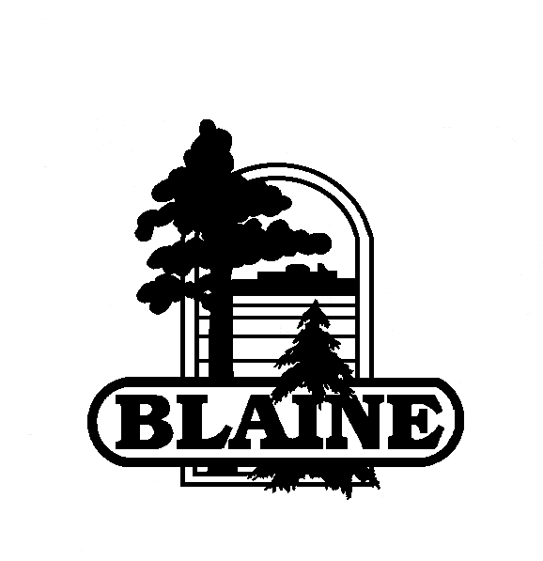

MEMO
■ OFFICE OF THE CITY MANAGER

DATE: | October 17, 2013
TO: | Mayor and City Council members
FROM: | Clark Arneson, City Manager
SUBJECT: | Economic Development Authority Future Issues
- Do we agree with the 3 Economic Development Goals adopted in 2009?
- EDA – What is the future of the EDA and what role does it play in Blaine’s future development and redevelopment?
- How are we going to staff the EDA?
- How are we going to finance operations or capital costs?
- How do we know if we have achieved our goals?

