I-35W North Preliminary Design
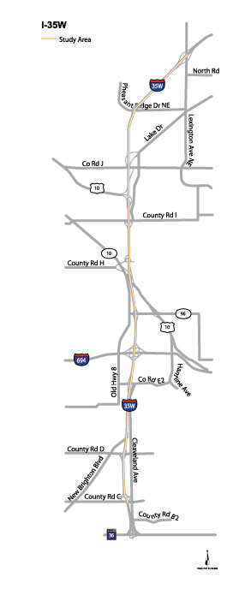
What is the focus of the I-35W North Preliminary Design?
- Adding a MnPASS lane, in each direction, to Interstate 35W North between CR C in Roseville and Lexington Avenue (County Road 17) in Blaine
- Improvements along the corridor to address safety issues
- Repave all lanes with concrete from CR C in Roseville to Sunset Drive (CR 53) in Lino Lakes.
- Build noise walls where feasible and cost effective

Why does I-35W North need improvements?
- 53,000-127,000 vehicles per day and increasing traffic
- Unreliable travel due to congestion
- Unreliable transit travel times
- Safety along the corridor is compromised at some locations

What is MnPASS?
- A state transportation system that provides a congestion-free travel option during peak-drive times on roadways with high levels of congestion
- Free for transit users, carpoolers (including passengers who are children), motorcycles
- Free use for all travelers during non-peak periods (about 90% of the time)
- Fees for people driving alone during peak periods (6-10 a.m. and 3-7 p.m. weekdays) – fee varies based on level of congestion and may range from $0.25 to $8

How much will the project cost?
- $200 to $210 million
- Full funding not yet identified

When will construction start?
- 2019, if funding becomes available

What happens next?
- Preliminary engineering completed by mid-2016
- Environmental Assessment completed by Winter 2016

For more information contact:
Jerome Adams Bobbie Dahlke
MnDOT Project Manager MnPASS Communications Coordinator
(651) 234-7611 (651) 234-7088
Jerome.Adams@state.mn.us Bobbie.Dahlke@state.mn.us

Stay informed! Sign up to receive email updates: mndot.gov/metro/projects/i35wroseville/

