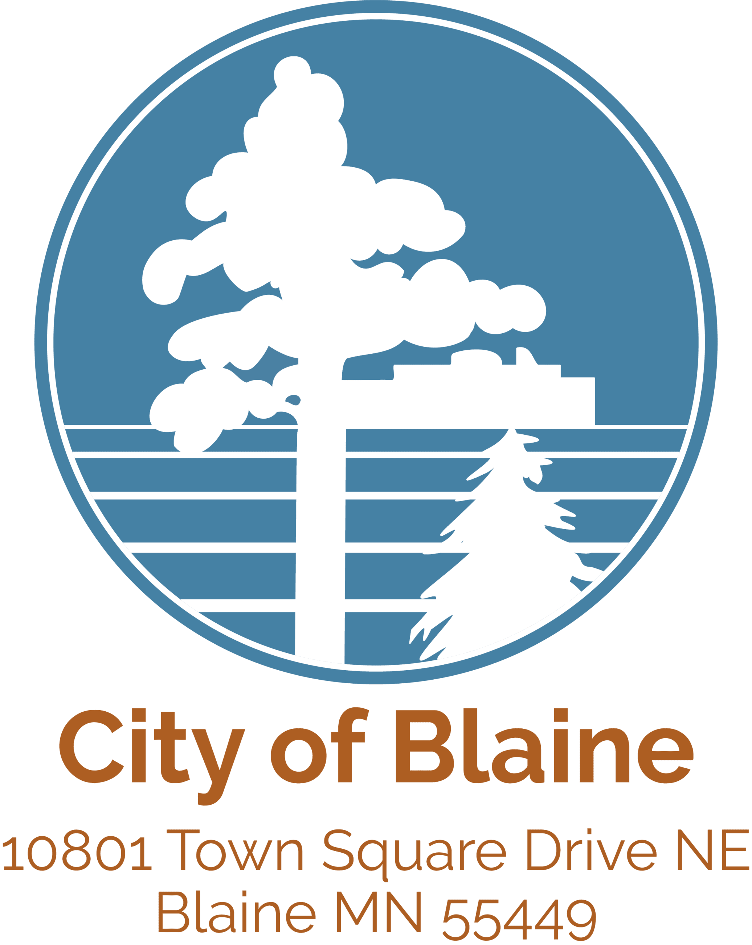

2021 Consulting Services
General Municipal
1. Bolton & Menk
2. SEH
3. WSB

2021 Consulting Technical/ Specialty Services
Architectural | Communications | Electrical/  Mechanical | Land Surveying
- SRF  - WSB | - Bolton & Menk  - Kimley-Horn | - TKDA  - BARR | - EG Rud and Sons  - Carlson McCain

Natural Resources | Soils and Materials | Structural | Traffic/  Transportation
- SEH  - SRF  - BARR | - Braun  - Haugo | - Bolton&Menk  - Kimley-Horn | - SEH  - SRF  - WSB

Relocation
- SRF
- TKDA

