JOINT POWERS AGREEMENT
FOR THE IMPLEMENTATION OF
THE PLEASURE CREEK IRON ENHANCED SAND FILTER PROJECT

This Agreement is made and entered into this ____ day of ______________, 2019, by and between the Coon Creek Watershed District, a metropolitan watershed district and political subdivision of the State of Minnesota, 12301 Central Avenue NE Suite 100, Blaine, Minnesota 55434, hereinafter referred to as the "District”, and the City of Blaine, a Minnesota municipal corporation, 10801 Town Square Drive NE, Blaine, Minnesota 55449, hereinafter referred to as the "City".

WITNESSETH
WHEREAS, The District and the City share a common interest in improving water quality in Pleasure Creek located within the City of Blaine and within the Coon Creek Watershed District; and

WHEREAS, The District intends to construct an iron enhanced sand filter between the intersection of Clover Leaf Parkway/East Pleasure Creek Parkway and stormwater pond #303, to reduce total phosphorus and E. coil loading and the City is in agreement to said project; and

WHEREAS, The District has been awarded partial state grant funding to design and construct this water quality improvement project; and

WHEREAS, Minnesota Statutes section 471.59 authorizes political subdivisions of the State of Minnesota to enter into joint powers agreements for the joint exercise of powers common to each.

NOW, THEREFORE, IT IS MUTUALLY STIPULATED AND AGREED AS FOLLOWS:

- PURPOSE
The District and City agree that it is mutually beneficial for the District to undertake the implementation of the iron enhanced sand filter project (“Project”) to reduce total phosphorus and E. coli loading in Pleasure Creek.

- METHODS
  - Preliminary Planning/Approval
The District, in consultation with the City, shall provide for the planning, engineering, construction, and construction administration for the Project.

  - Design
The District shall be responsible for all engineering and design services and will prepare plans and specifications for the Project in consultation with the City. The District shall not go out for bids until such time as the City has approved, in writing, the plans and specifications for the Project. 60% Design Plans developed by the District Engineer are attached as Exhibit A.

  - Bidding/Construction
The District shall do the calling for all bids and the accepting of all bid proposals, and shall cause the construction of the Project in conformance with the approved plans and specifications. The award of the bid to the lowest responsible bidder shall be made in consultation with the City prior to the execution of the construction contract. After receipt of all necessary governmental approvals, the District shall cause the commencement of the Project's construction and shall manage the Project through to completion.

- COST ALLOCATION
  - The total estimated cost of completing the Project is $480,365.50.
  - The District has received a Clean Water Fund Watershed Based Funding grant administered by the Minnesota Board of Water and Soil Resources in the amount of $95,986.50 and will apply these funds towards the total Project costs incurred.
  - The District shall contribute up to $184,379 for engineering and construction costs.
  - The City shall contribute up to $200,000 for construction costs and may incur minimal costs for City staff time related to Project coordination.

- SITE ACCESS
The City agrees to grant the District and its contractors and agents access to the portions of the Project site on City-owned land for Project construction and future inspection. The City agrees that the District may install interpretative signage at the Project site to educate visitors on water quality and best management practices.

- TERM / TERMINATION
This Agreement shall continue in full force and effect for the expected life span of the project, 25 years post-construction, or until terminated as hereinafter provided.

- CONTRACTS AND PURCHASES
A. All contracts let and purchases made pursuant to this Agreement shall be made by the District in conformance to State laws. All contracts shall contain the following indemnification paragraph:
- The Contractor agrees that it will hold harmless, indemnify, and defend Blaine, its council members, officers, agents and employees against any and all claims, expenses, losses, damages or lawsuits for damages arising from or related to the negligent provision, or failure to provide, services hereunder.

B. All contracts shall include the insurance requirements as set forth in Exhibit C, which is attached hereto and incorporated herein.

- STRICT ACCOUNTABILITY
A strict accounting shall be made of all funds and report of all receipts and disbursements shall be made upon request by either party.

- MAINTENANCE OF IMPROVEMENTS
The City will assume responsibility of future maintenance of the Project components as outlined in the Operations and Maintenance plan attached in Exhibit B.

- NONCOMPLIANCE
Should the land occupier fail to maintain the practice during its effective life, the land occupier is liable to the State of Minnesota for the amount up to 150% of the amount of financial assistance received to install and establish the practice unless the failure was caused by reasons beyond the land occupier’s control, or if conservation practices are applied at the land occupier’s expense that provide equivalent protection of the soil and water resources.

- NOTICE
For purposes of delivery of any notices hereunder, the notice shall be effective if delivered to the District Administrator, 12301 Central Avenue NE Suite 100, Blaine, Minnesota 55434, on behalf of the District, and to the City Manager for the city of Blaine, 10801 Town Square Drive NE, Blaine, Minnesota 55449, on behalf of the City.

- INDEMNIFICATION
The District and City mutually agree to indemnify and hold harmless each other from any claims, losses, costs, expenses or damages resulting from the acts or omissions of the respective officers, agents, or employees relating to activities conducted by either party under this Agreement.

- ENTIRE AGREEMENT / REQUIREMENT OF WRITING
It is understood and agreed that the entire agreement of the parties is contained herein and that this Agreement supersedes all oral agreements and all negotiations between the parties relating to the subject matter thereof, as well as any previous agreement presently in effect between the parties to the subject matter thereof. Any alterations, variations, or modifications of the provisions of this Agreement shall be valid only when they have been reduced to writing and duly signed by the parties.

- GOVERNMENT DATA PRACTICES
The District and City will comply with the Minnesota Government Data Practices Act, Minnesota Statutes Chapter 13, as amended, as it applies to all data created, collected, received, stored, used, maintained or disseminated by the District or the City under this Agreement.

IN WITNESS WHEREOF, the parties of this Agreement have hereunto set their hands on the dates written below:

Coon Creek Watershed District: City of Blaine:

By: ___________________________ By: ___________________________
Anthony Wilder, President, Board of Managers Tom Ryan, Mayor

Dated: _________________________ Dated: _________________________

By: ___________________________ By: ___________________________
Tim Kelly, District Administrator Clark Arneson, City Manager

Dated: _________________________ Dated: _________________________
--Page intentionally left blank--
Exhibit A 60% Design Plans

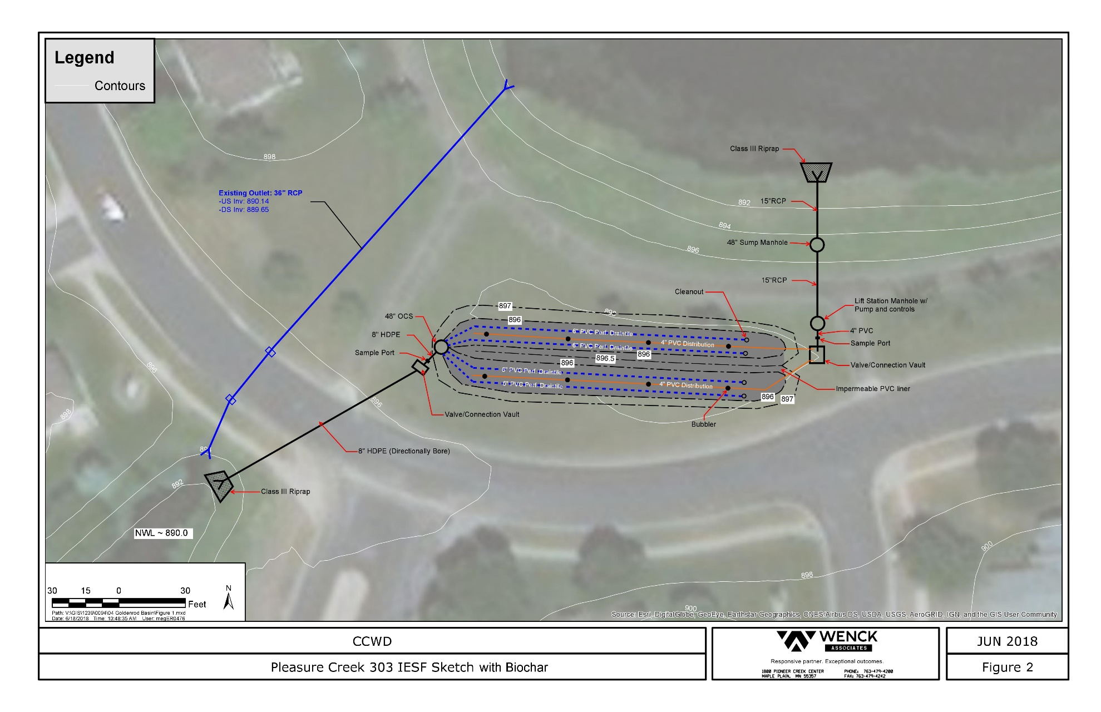

Exhibit B

Pleasure Creek Iron-Enhanced Sand Filter

BMP Operations and Maintenance Plan

The intent of this plan is to ensure the long-term efficacy of the Pleasure Creek iron-enhanced sand filter (IESF). This effort will involve both the Coon Creek Watershed District (CCWD) and the City of Blaine, with the goal of maximizing and sustaining the effectiveness of this practice. This plan was developed based on maintenance plans for similar stormwater treatment systems and from conversations with stormwater professionals who have worked directly with IESFs in the field and laboratory. As this is an emerging technology, there is no long-term data to judge maintenance needs or horizons over the project’s lifetime with certainty. This plan will need to be updated as more information is gained concerning these practices.

Operations and Maintenance needs of this practice are summarized in this document within two categories:
- Inspections and maintenance
- Performance monitoring

The frequency of these actions will be adjusted based on filter performance and resources of the project partners.

Inspections and Maintenance
Following installation, on-site inspections of the project should be performed to ensure the practice is operating at design capacity. Routine inspection and maintenance will be handled by the City of Blaine. The CCWD may provide guidance and technical assistance as needed. Media replacement will be coordinated jointly and financed by the CCWD. Specific items to look for during each inspection are summarized on the inspection form, included on pages 3 and 4 of this document. Inspections should occur often enough to ensure that performance below design capacity can be addressed quickly. Monthly inspections are recommended during the first treatment season following installation. Less frequent inspection may occur in subsequent years, but should occur at least seasonally in early spring, mid-summer, and fall in years 2-5 and annually thereafter. Inspections should occur recently after storm events such that filter appearance, drawdown, and overall function can be assessed during a single visit.

Summarized below are other important notes for visual inspections:

- The IESF should be inspected for:
  - Media - a hard crust at the surface that appears impermeable or does not break apart easily
  - Media - a gray muck or clay-like build-up (may feel slimy to the touch) the material should be removed and replaced with clean sand and/or a sand-iron mix matching the designed ratio.
  - Media - sediment and/or organic debris accumulation on the top of the IESF in a manner that inhibits infiltration through the IESF. (note: If the rate of sediment and organic matter accumulation on the IESF increases, it may indicate that the capacity of the pond to settle and store solids is compromised).
  - Media – hard encrusted gray or black layers deeper in the media
  - Liner – evidence of leakage
  - Pump – evidence of blockage or failure

- If any of the conditions in 1(a-d) above are noted it should be remedied immediately, as it can adversely affect filtration rates. If conditions described in 1(a-c) are noted, remove accumulation and loosen the surface layer of the media with a rigid tined rake. If the conditions noted in 1(d) are present, these aggregates have been known to limit flow through IESF systems and can significantly reduce performance. If these are found, a thorough tilling of the filter media or even replacement of the entire filter media may be necessary as this is often evidence of either (i) poor iron-sand mixing prior to installation or (ii) development of a confining layer.

Performance Monitoring
BMP effectiveness in reducing phosphorus and E. coli export to Pleasure Creek is best determined through analysis of water quality samples. The CCWD will be responsible for coordinating monitoring. The frequency of sampling should occur often enough to adequately determine BMP efficacy. It is recommended that high resolution monitoring is performed within the first three years to test for E. coli removal, phosphorus retention, or potential phosphorus and/or iron leaching from the IESF. This could include monitoring at least once per month in the first three years and bi-monthly monitoring for years 4-5 and every five years thereafter. Monitoring frequency should be adjusted to adequately determine the efficacy of maintenance actions, such as skimming a top layer to improve infiltration or replacing filter media.

Water quality samples should be taken from both the inlet to the IESF (i.e. pond) and from the IESF outlet to determine water chemistry changes within the practice. Key constituents to measure include E. coli, total phosphorus (TP), and dissolved phosphorus (ortho P; OP). Dissolved oxygen and pH should be measured if P leaching is observed. MPCA guidelines for sample preparation and analysis should be followed for all samples acquired.

If multiple P measurements taken at the IESF outlet exceed baseline concentrations from the first 2 years and/or exceed water quality standards, phosphorus binding sites within the filter media may have been exhausted. If this occurs, samples of the sand-iron media should be collected and analyzed to determine the ratio between TP and total iron. TP to total iron ratios that exceed 5 mg-TP per 1 g of elemental iron indicate that phosphorus binding sites have reached capacity and that the filter media should be replaced.

While paired grab samples of E. coli and P concentrations from the filter inflow and effluent will provide information on bacteria and nutrient removal efficacy, hydrologic analysis is needed to estimate the annual load reductions to Pleasure Creek and to identify changes in the media infiltration rates. Because this is a pump-based system, the volume of water treated can be calculated based on the pumping rate. Pump operation records should be maintained.

NOTE: The iron filings using in IESFs may be very sharp and/or abrasive. Signs should be maintained warning the public of this hazard and maintenance staff should take appropriate precautions when working with the media.
Pleasure Creek IESF Inspection Form

Date of Inspection:
Inspector’s name(s):
Time since last rainfall (hr):
Quantity of last rainfall (in):
Were monitoring samples taken as part of the inspection (Yes or No):
If Yes, how many samples taken:
Which constituents will be analyzed:
Date of sample analysis:
Does pump appear operational (Yes or No):
Are both cells receiving untreated water (Yes or No):
Is water exiting the practice outfall (Yes or No):
If Yes, does effluent water have any special characteristics (iron color, odor, slow discharge, etc.):

Maintenance Item | S | U | Comments/Actions Required
1. Debris Cleanout
Filter area clear of trash and debris
Control structure clear of trash and debris
2. Vegetation
Deep-rooted vegetation removed from on and around the filter bed
3. Sediment Deposition
Evidence of sediment deposition on filter bed
4. Sand media
Condition of media (evidence of discoloring, clumping, clogging)
5. Outlet / Inlet Condition
Condition of outlet control structure from IESF and pond (evidence of blowout, clogging, large deposition of sediment)
Condition of flared-end outlet into the ditch - north of the park trail (evidence of blowout, clogging, large deposition of sediment)
Condition of inlet bench from pond (evidence of sloughing, leakage)
6. Cleanout Riser Condition
Condition of cleanout risers (6 total)
7. Dewatering
Evidence of leakage from pond to IESF
Evidence of filter clogging (if yes, see notes on page 1 for corrective actions)
8. Structural Integrity
Condition of embankment (evidence of leaks, holes, slope failures, woody vegetation)
Evidence of structural damage (leaks, cracks, etc)
9. Overall IESF functionality
Evidence of odors (gasoline, oil, rot, etc.)
Evidence of flow bypass
10. Overall Pond functionality
Sediment deposition in the pond that threatens IESF performance
11. Miscellaneous Items:
S=Satisfactory U-Unsatisfactory
Maintenance actions taken: [If any of the above items were marked unsatisfactory, explain the actions taken and time table for correction. Attach additional pages as necessary.]

______________________________________________________________________________________________________________________________________________________________________________________________________________________________________________________________________________________________________________________________________________________________________________________________________________________________________________________________________________________________________________________________________________________________________________________________________________________________________________________________________________________________________________________________________________________________________________________________________________________________________________________________________________________________________________________________________________________________________________________________________________________________________________________________________________________________________________________________________________________________________________________________________________________________________________________________________________________________________________________________________________________

Additional comments:

______________________________________________________________________________________________________________________________________________________________________________________________________________________________________________________________________________________________________________________________________________________________________________________________________________________________________________________________________________________________________________________________________________________________________________________________________________________________________________________________________________________________________________________________________________________________________________________________________________________________________________________________________________________________________________________________________________________________________________________________________________________________________________________________________________________________________________________________________________________________________________________________________________________________________________________________________________________________________________________________________________________

EXHIBIT C
CONSTRUCTION/MAINTENANCE
INSURANCE REQUIREMENTS

The Contractor shall obtain and maintain in full force for the duration of the contract the insurance designated as follows.

Worker's Compensation: The Contractor shall take out and maintain during the life of the contract, Worker's Compensation Insurance for all of his employees employed at the work site. If any employees are engaged in hazardous work not covered by Worker's Compensation Insurance, the Contractor shall provide adequate protection from Employer's Liability Insurance for protection of employees not otherwise protected.

Liability Insurance Requirements (Liability and Auto): Contractor shall maintain commercial general liability (CGL), and if necessary commercial umbrella insurance, with a limit of not less than $1,000,000 each occurrence. If such CGL insurance contains a general aggregate limit, the general aggregate limit shall be not less than $2,000,000 and the aggregate limit shall apply on a per-project basis. The CGL insurance shall cover liability arising from premises, operations, independent Contractors, products-completed operations, personal injury and advertising injury, and Contractually-assumed liability. The City of Blaine shall be named as an additional insured under the CGL.

Contractor shall maintain automobile liability insurance, and if necessary, umbrella liability insurance with a limit of not less than $1,000,000 each accident. If such insurance contains a general aggregate limit, the general aggregate limit shall be not less than $2,000,000. The insurance shall cover liability arising out of any auto, including owned, hired, and non-owned autos.

A certificate of insurance acceptable to Blaine shall be filed prior to the commencement of the work. The certificate and the required insurance policies shall contain a provision that the coverage afforded under the Contract will not be canceled or allowed to expire until at least 30 days prior written notice has been given.

Fire Insurance: The Contractor shall carry full insurance against loss by fire and wind damage upon all material in place or stored at the site for installation. This provision does not exclude material partially paid for by the Owner. This insurance shall be for the full insurable value of the material and shall be kept in full force until final acceptance and payment of the work by the Owner.

If any section of the work entails special hazards the Contractor shall provide riders to the Public Liability and Property Damage Insurance to provide protection from these special hazards.

