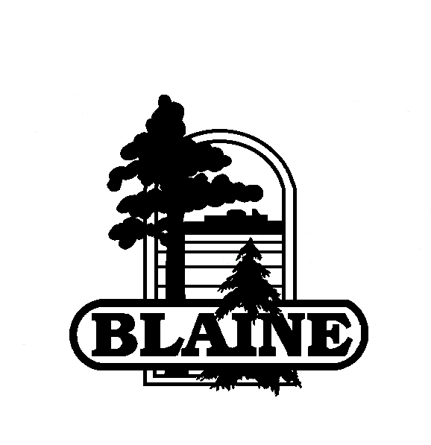

MEMO
CITY OF BLAINE  PARKS AND RECREATION

DATE: | February 8, 2013
TO: | Bob Therres, Public Services Manager
FROM: | Jim Kappelhoff, Park and Recreation Director
RE: | City of Roseville Park Maintenance and Improvement Bonds
I spoke with Jill Anfang, Roseville Assistant Park and Recreation Director, on the early process of their park maintenance and improvement bond project. Keep in mind project was funded through bonds issued by using Port Authority powers and bonds issued in this manner are not subject to public referendum. Their City Council approved the bonds in 2012 by a 3-2 vote. It includes $2 million in renovations to the park system in the first phase and $19 million over 3 years. The following is the process leading up to the approved bond project.

- Staff and Park Commission brought the need for community wide park maintenance and improvements to the City Council.

- City Council authorized the development of a master plan for all parks and a consultant, LHB, was contracted from RFP’s to implement the plan in 2011. It included what was the community vision of the parks and a community survey was conducted.

- After the master plan was developed a citizen task force was assembled. All residents were invited to apply and 28 members were accepted. The task force determined the feasibility of a park improvement plan, how to determine the needs and give direction for the plan. A consultant was on board for this process. They also included a community center and some parkland acquisition in the plan.

- Once the task force was completed with determining feasibility and needs assessment, a second task force was formed to develop an implementation plan. They engaged the community and assigned work groups to different pieces of the plan, i.e., playgrounds, athletic facilities, park buildings. The entire time the Park Commission was involved in this process.

- Once the task force work was completed the consultant packaged up the park maintenance and improvement plan and presented it to the Park Commission who then recommended it to the City Council. They approved the $19 million bond price tag.

